**BEST PRACTISES TO WRITE**

**ENTERPRISE LEVEL REACT JS CODE.**

1. **FILE & FOLDER STRUCTURE.**

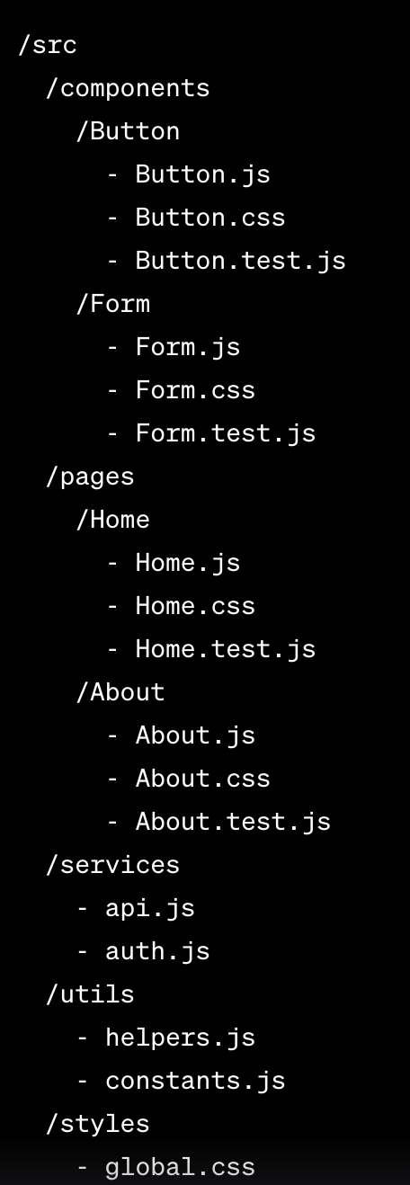

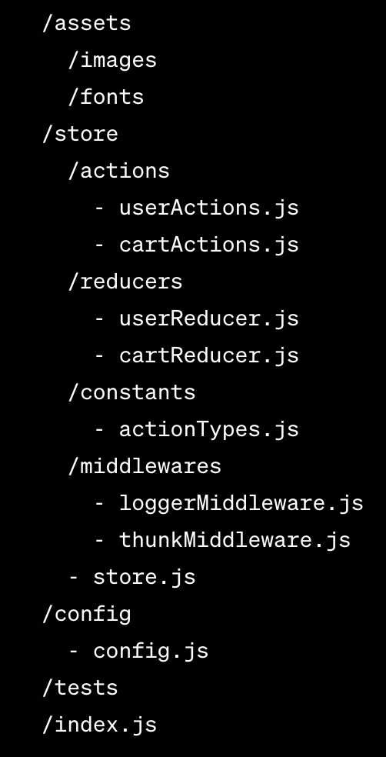

1. **/src :** is the main folder for your source code:
   1. This folder serves as the root directory for your React.js project. It contains all the code and assets related to your application.
   2. Example: /src/App.js, /src/index.js
2. **/components** folder contains reusable UI components organized by feature or functionality:
   1. This folder houses reusable components that can be used throughout your application.
   2. Example: /src/components/Button/Button.js, /src/components/Form/Form.js
3. **/pages** folder contains components that represent individual pages or views in your application:
   1. This folder holds components that represent the different pages or views of your application.
   2. Example: /src/pages/Home/Home.js, /src/pages/About/About.js
4. **/services** folder contains modules responsible for interacting with APIs or external services:
   1. This folder contains modules or files responsible for handling API calls or interacting with external services.
   2. Example: /src/services/api.js, /src/services/auth.js
5. **/utils** folder holds utility modules or helper functions:
   1. This folder contains utility functions or helper modules that can be used across your application.
   2. Example: /src/utils/helpers.js, /src/utils/constants.js
6. **/styles** folder contains global styles or stylesheets specific to components**:**
   1. This folder contains CSS files or stylesheets specific to your components or global styles for your application.
   2. Example: /src/styles/global.css, /src/components/Button/Button.css
7. **/assets** folder contains static assets like images and fonts:
   1. This folder stores static assets such as images, fonts, or other files required by your application.
   2. Example: /src/assets/images/logo.png, /src/assets/fonts/Roboto.ttf
8. **/store** folder contains files related to state management using a library like Redux:
   1. This folder is dedicated to managing the application's state using Redux or a similar state management library.
   2. Example: /src/store/actions/userActions.js, /src/store/reducers/userReducer.js
9. **/config** folder contains configuration files for your project:
   1. This folder holds configuration files for your project, such as environment-specific settings or API endpoints.
   2. Example: /src/config/config.js
10. **/tests** folder contains your unit or integration tests:
    1. This folder houses your tests, including unit tests or integration tests for your components or functions.
    2. Example: /src/tests/Button.test.js, /src/tests/Form.test.js
11. **/index.js** is the entry point of your application:
    1. This file serves as the main entry point of your application and is responsible for rendering the root component.
    2. Example: /src/index.js